**Aim -** Study of Version Control System/Source Code Management,

install git and create a GitHub Account.

**Theory –**

A Version Control System is a software tool that helps manage changes to source code over time. [It keeps track of every modification made to the code, allowing developers to revert to previous versions, compare changes, and collaborate seamlessly](https://www.geeksforgeeks.org/version-control-systems/).

Types of VCS –

There are three main types of version control systems:

* Local Version Control Systems: These keep track of files within the local system.
* Centralized Version Control Systems (CVCS): These use a single server to store all changes and file versions, making collaboration easier.
* [Distributed Version Control Systems (DVCS): These allow every contributor to have a local copy of the entire project history, enhancing collaboration and redundancy](https://www.atlassian.com/git/tutorials/what-is-version-control)

Benefits of Using a VCS -

* Collaboration - Multiple developers can work on the same project simultaneously without conflicts.
* Backup and Restore - Easily revert to previous versions if something goes wrong.
* Track Changes - See who made what changes and when.
* Branching and Merging - Work on new features or fixes in isolation and merge them when ready.
* [Improved Productivity - Streamlines the development process and reduces errors](https://www.geeksforgeeks.org/version-control-systems/).

How To Install Git Bash On Windows:

Download Git Bash

• Step 1: Visit the Official Git Bash Website

• Step 2: Bash Download Install Git Bash

• Step 3: Run the Installer

• Step 4: Select Destination Location

• Step 5: Select Components

• Step 6: Select Start Menu Folder

• Step 7: Choose the Default Editor used by Git

• Step 8: Adjust your PATH Environment

• Step 9: Choose HTTPS Transport Backend

• Step 10: Configure the Line Ending Conversions

• Step 11: Configure the Terminal Emulator to use with Git Bash

• Step 12: Configuring Extra Options

• Step 13: Configuring Extra

• Step 14: Wait for Installation

• Step 15: Complete the Git Setup Wizard

**Output :**

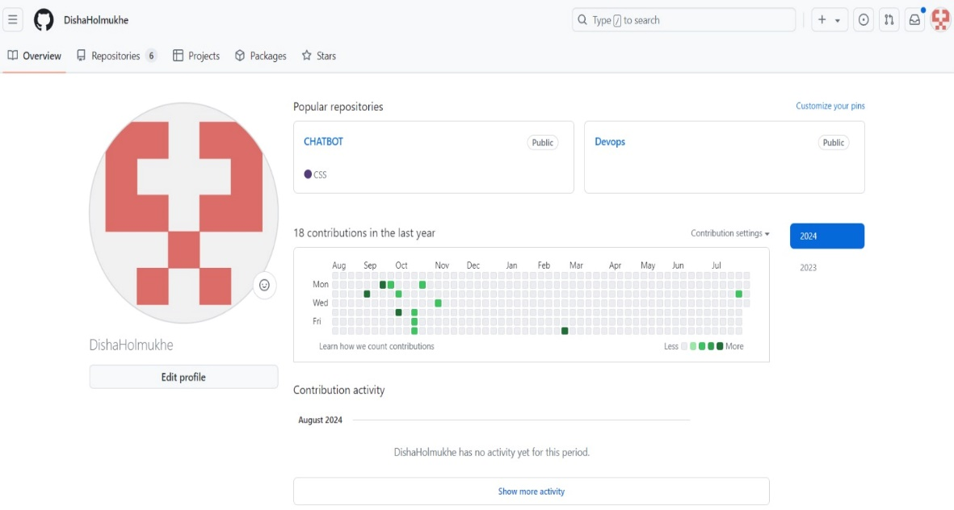

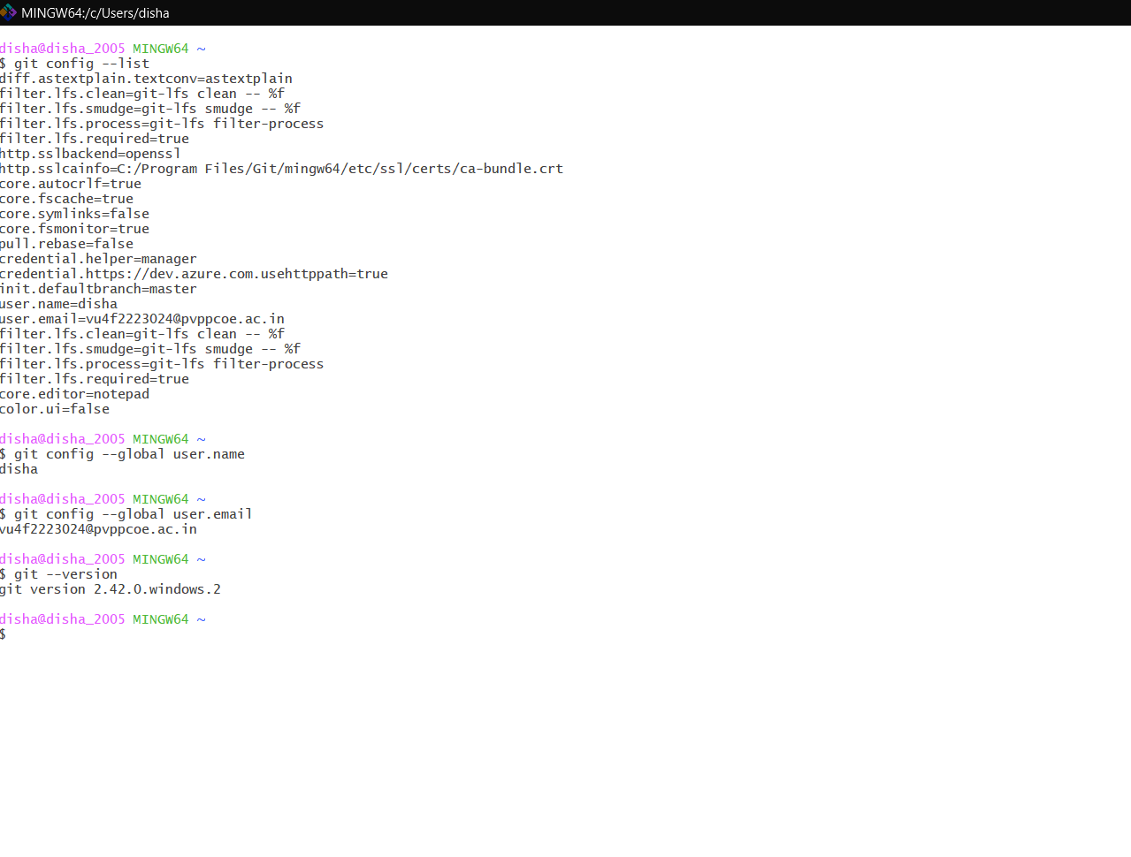

**Conclusion:** Study of Version Control System/Source Code Management,

install git and create a GitHub Account was successfully done.